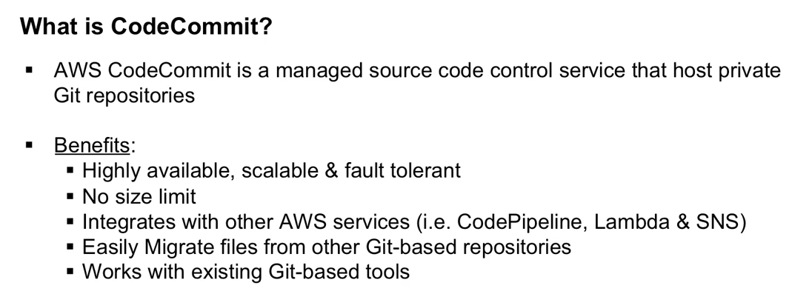

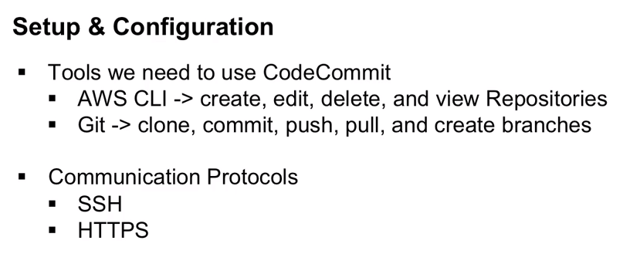

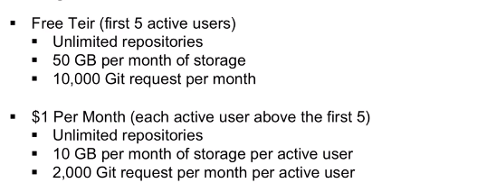

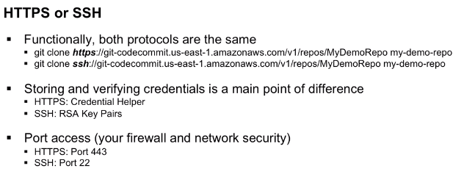

With ssh connection, we use RSA key pair (Public and private key files on local machine).We associate public key with the IAM user and private key on the local machine.

gitconfig --global –edit //For checking and modifying the git credentials using code commit.

1. These credentials will only stay for 50 minutes, after that it won’t work.

There are two solutions for the same, they are

a)Find a version of git that doesn’t use key change by default.

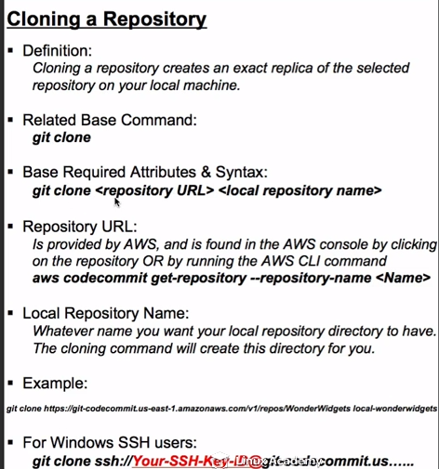

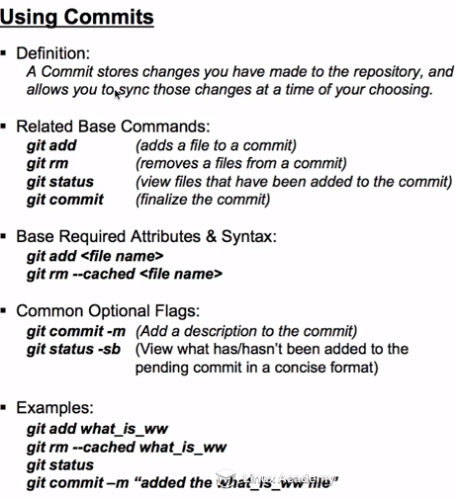

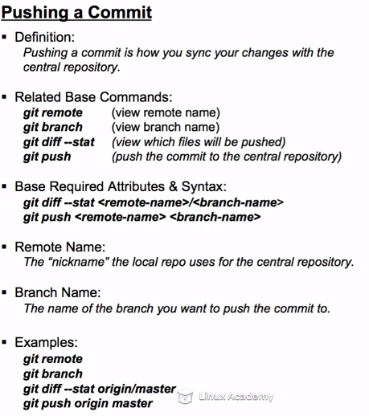

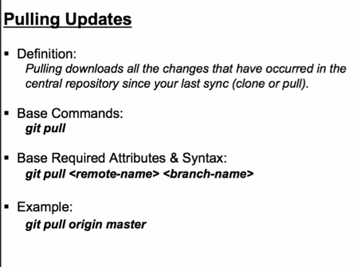

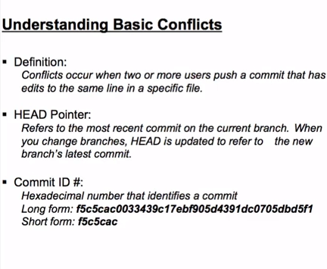

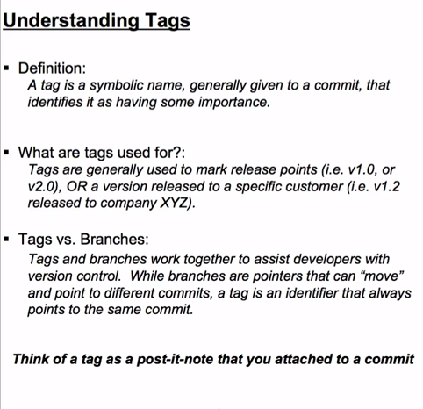

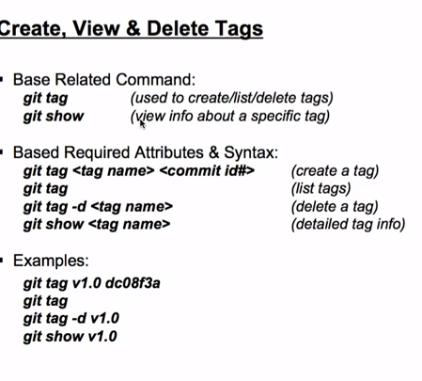

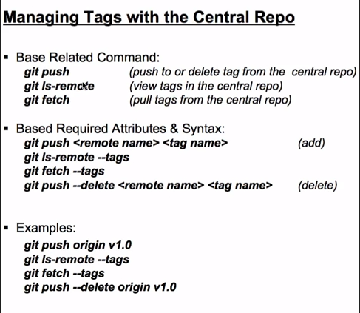

**We can migrate other SCM tools to CodeCommit also.**

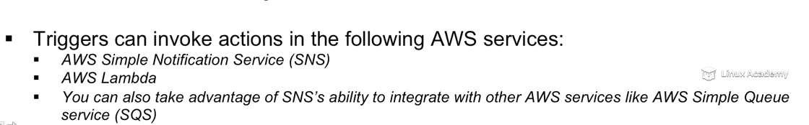

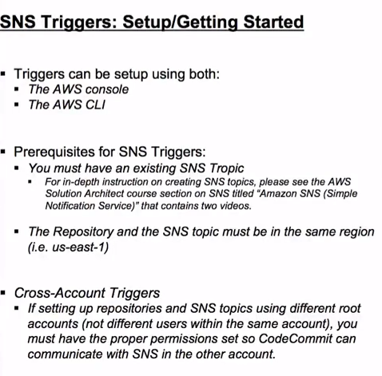

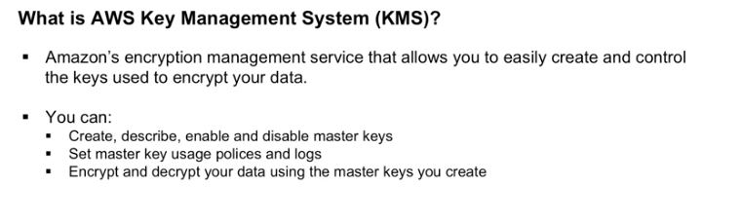

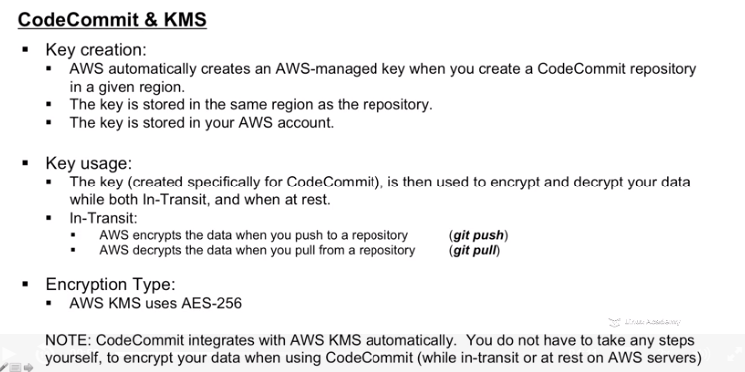

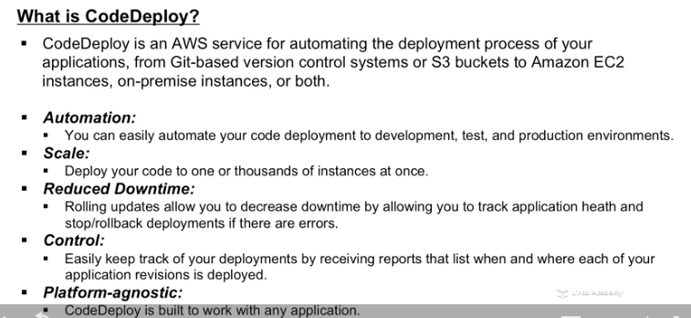

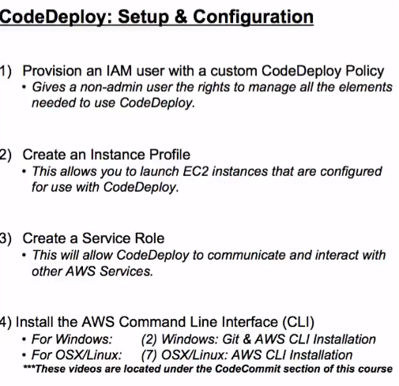

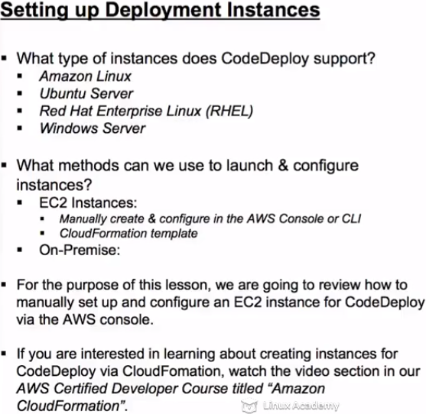

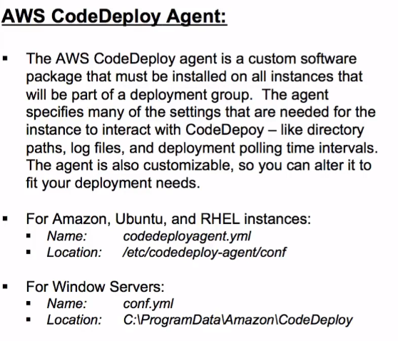

After installing Code-deploy on all EC2 instances where we want to run code deploy,

service codedeploy-agent status //For checking code deploy is installed or not

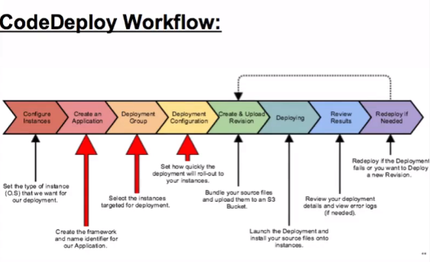

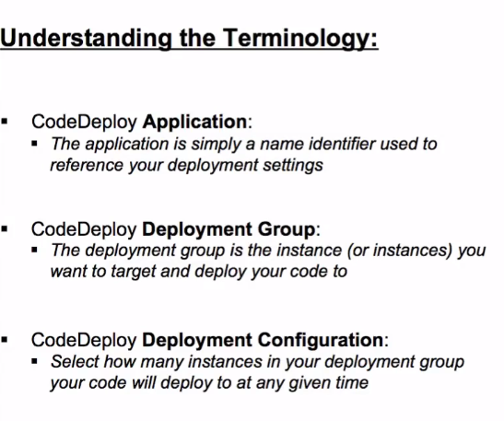

Deployment configuration three types – One at a time, All at once, Half at a time

Deployment types are two

[**In-place deployment**](https://console.aws.amazon.com/codedeploy/home?region=us-east-1)

Updates the instances in the deployment group with the latest application revision. During a deployment, each instance will be briefly taken offline for its update.

[**Blue/green deployment**](https://console.aws.amazon.com/codedeploy/home?region=us-east-1)

Replaces the instances in the deployment group with new instances and deploys the latest application revision to them. After instances in the replacement environment are registered with a load balancer, instances from the original environment are deregistered and can be terminated.

Environment Configuration

Specify any combination of Auto Scaling groups, Amazon EC2 instances, and on-premises instances to add instances to this deployment group.

We can only edit the name of the application using CLI or API.

We can have multiple deployment groups for a single deployment application.

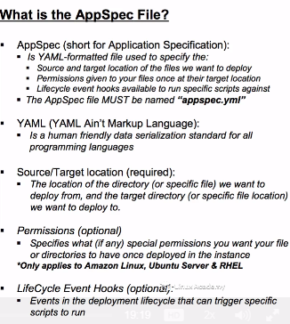

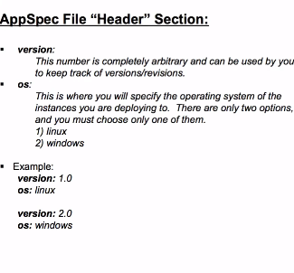

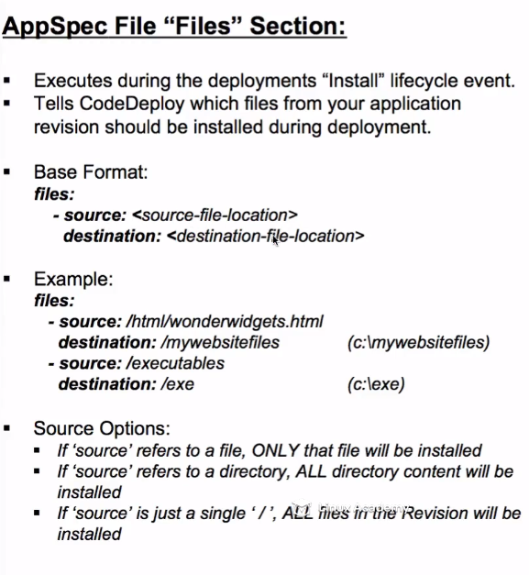

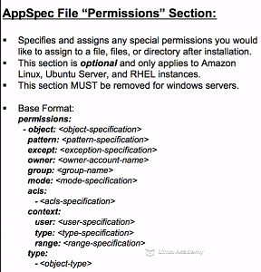

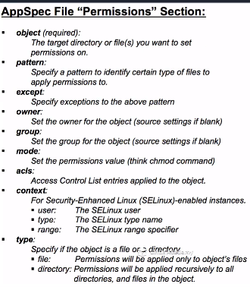

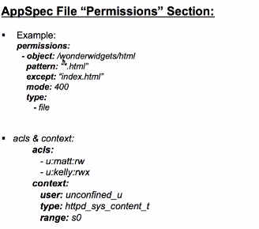

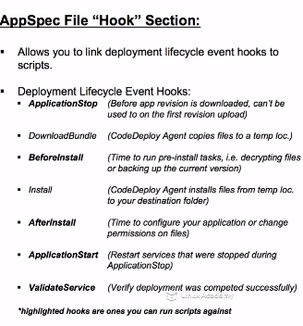

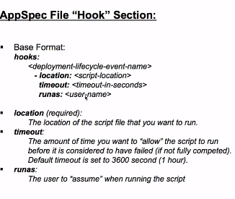

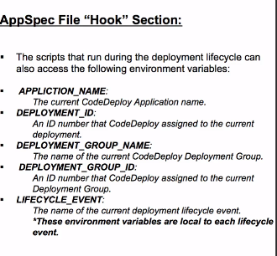

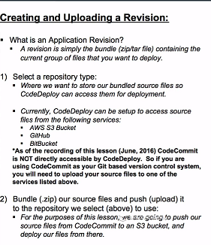

AWS CodeDeploy provides three default deployment configurations that have commonly used minimum healthy host values:

|  |  |
| --- | --- |
| **Default deployment configuration name** | **Predefined minimum healthy hosts value** |
| CodeDeployDefault.OneAtATime | 99% |
| CodeDeployDefault.HalfAtATime | 50% |
| CodeDeployDefault.AllAtOnce | 0 |

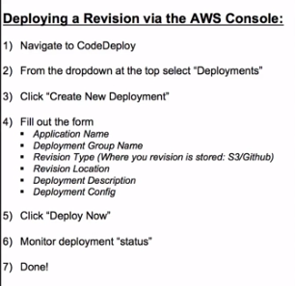

|  |  |
| --- | --- |
| **Error Code** | **Description** |
| AGENT_ISSUE | The deployment failed because of a problem with the AWS CodeDeploy agent. Make sure the agent is installed and running on all instances in this deployment group. |
| HEALTH_CONSTRAINTS | The overall deployment failed because too many individual instances failed deployment, too few healthy instances are available for deployment, or some instances in your deployment group are experiencing problems. |
| HEALTH_CONSTRAINTS_INVALID | The deployment can’t start because the minimum number of healthy instances, as defined by your deployment configuration, are not available. You can reduce the required number of healthy instances by updating your deployment configuration or increase the number of instances in this deployment group. |
| IAM_ROLE_MISSING | The deployment failed because no service role exists with the service role name specified for the deployment group. Make sure you are using the correct service role name. |
| IAM_ROLE_PERMISSIONS | AWS CodeDeploy does not have the permissions required to assume a role, or the IAM role you're using does't give you permission to perform operations in an AWS service. |
| AUTO_SCALING_IAM_ROLE_PERMISSIONS | The service role associated with your deployment group does not have the permission required to perform operations in the following AWS service. |
| OVER_MAX_INSTANCES | The deployment failed because more instances are targeted for deployment than are allowed for your account. To reduce the number of instances targeted for this deployment, update the tag settings for this deployment group or delete some of the targeted instances. Alternatively, you can contact AWS Support to request a limit increase. |
| THROTTLED | The deployment failed because more requests were made than are permitted for AWS CodeDeploy by an IAM role. Try reducing the number of requests. |
| UNABLE_TO_SEND_ASG | The deployment failed because the deployment group isn’t configured correctly with its Auto Scaling group. In the AWS CodeDeploy console, delete the Auto Scaling group from the deployment group, and then add it again. |

